**BUGS**

**Bug#1:**

**Description**: Validating the upward and downward arrow in the ‘Show Entries’

**Steps to Reproduce**: Open the ‘Existing Assets’ tab

In Show entries >> Click on the upward arrow

In Show entries >> Click on the downward arrow

**Expected Result**: The entries should be sorted according to the selection of the arrows.

**Actual Result**: Entries shown with the upward and downward arrow doesn’t work on clicking them; instead, it provides drop down for selection.

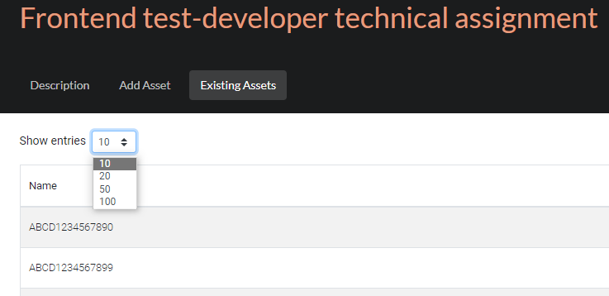

**Bug#2:**

**Description**: Validating the ‘SEND’ button.

**Steps to Reproduce**: Open the ‘Add Asset’ tab.

Without providing any data in the text field, click on ‘SEND’ button.

**Expected Result**: The ‘SEND’ button should be enabled only once the data is entered in the text field.

**Actual Result**: ‘SEND’ button is always enabled.

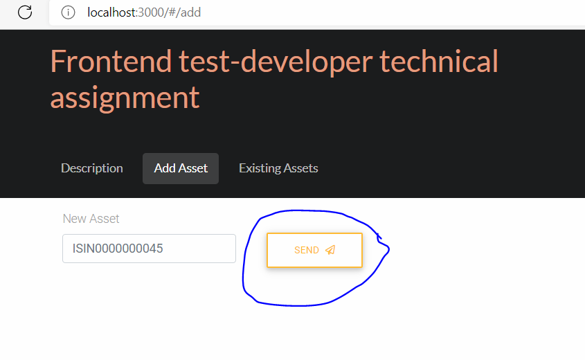

**Bug#3:**

**Description**: Validating the ‘Existing Assets’ tab.

**Steps to Reproduce**: Open the ‘Existing Assets’ tab during when the servers are down.

**Expected Result**: An error message should be displayed, incase of downtime issue.

**Actual Result**: It shows the loading sign when the ‘Existing Assets’ Page doesn’t load.

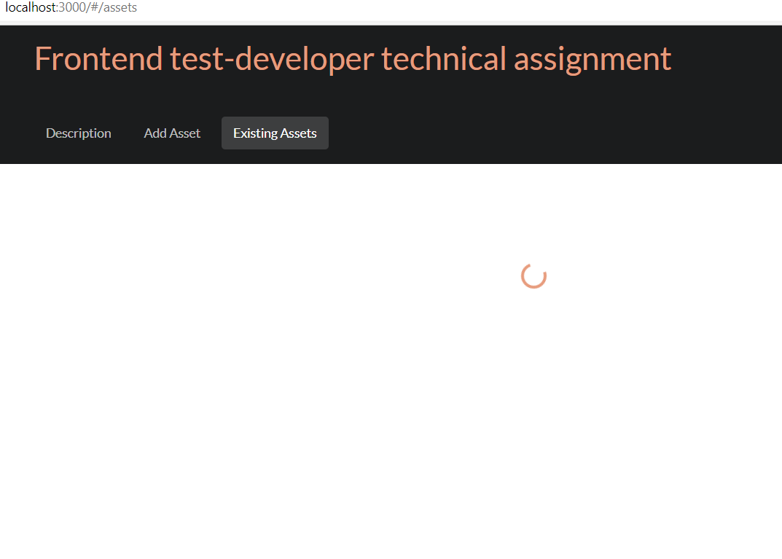

**Bug#4:**

**Description**: Validating the ‘Description’ tab.

**Steps to Reproduce**: Open the ‘Description’ tab.

Read the System requirements

**Expected Result**: There shouldn’t be any spelling mistakes.

**Actual Result**: Observed spelling mistakes in the description – **digitalis , abbility , assert**

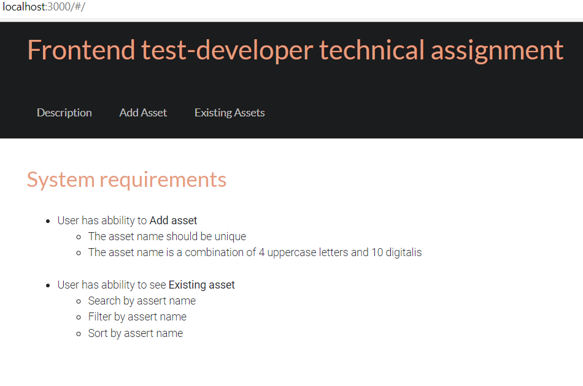

**Bug#5:**

**Description**: Validating the ‘Add Asset’ tab.

**Steps to Reproduce**: Open the ‘Add Asset’ tab.

Enter a unique value in the text box.

Hit ‘SEND’

**Expected Result**: There shouldn’t be any spelling mistakes.

**Actual Result**: There are spelling mistake in the word ‘Sucssess’

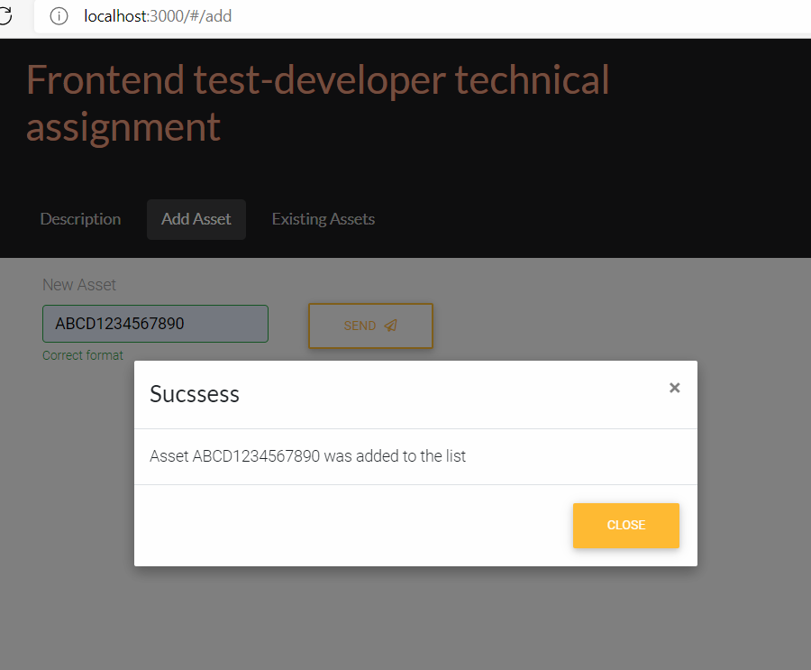

**Bug#6:**

**Description**: Validating the ‘Filter’ criteria in ‘Existing Assets’ tab..

**Steps to Reproduce**: Open the ‘Existing Assets’ tab.

Look for ‘Filter’ criteria.

**Expected Result**: As pet the System requirements, there should be option to filter the asses name’s .

**Actual Result**: ‘Filter’ criteria is not available in the ‘Existing Assets’

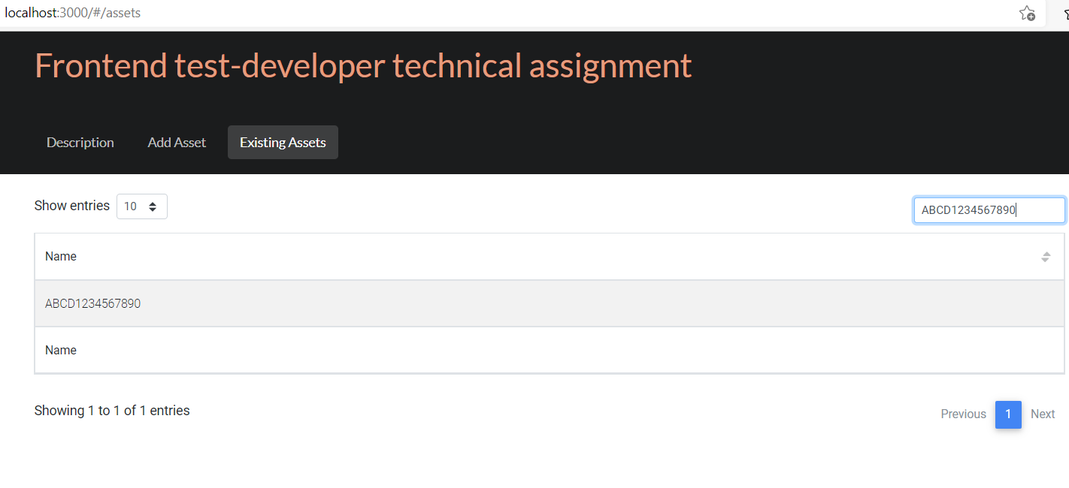

**Bug#7:**

**Description**: Validating the ‘Existing Assets’ tab.

**Steps to Reproduce**: Open the ‘Existing Assets’ tab.

Check the page content.

**Expected Result**: There should be only one Name field.

**Actual Result**: There are 2 Name fields displayed.

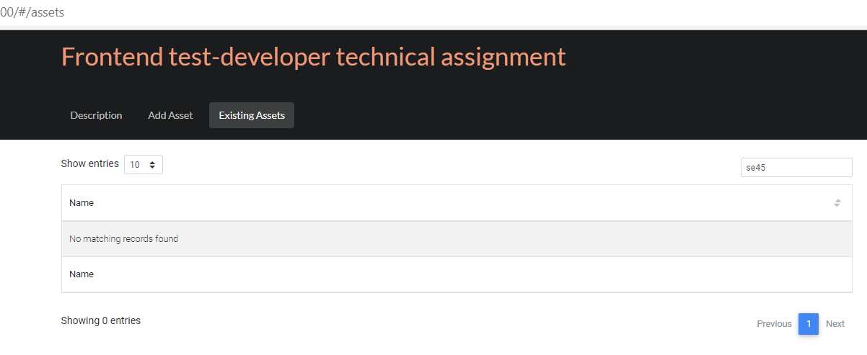

**Bug#8:**

**Description**: Validating the ‘Add Asset’ tab.

**Steps to Reproduce**: Open the ‘Add Asset’ tab.

Check the message prompt.

**Expected Result**: There shouldn’t be any spelling mistake in the message displayed.

**Actual Result**: There are spelling mistakes in the message displayed – **‘alredy’, ‘Assert’** .



